HIMANSU RANJAN BEHERA 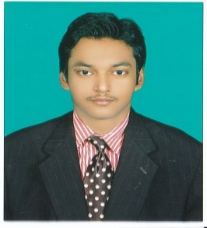

CO-CURRICULAR
ACTIVITES

- 2nd prize on “project display” event held in Techfest.
- Active member of “Electronics Hobby Club”.

HOBBIES
- Gardening.
- Teaching my youngsters.
- Helping my mom in cooking.
- Travelling.

PERSONAL DETAILS
- E-Mail:
hbehera91@gmail.com
- +918093117764

- Date of birth-
12th mar. 1995

- Languages known :
English,Hindi,odia

- Permanent Address :
AT-sahebzada bazar,
Po-chandini chowk,
Dist-cuttack
Pin-753002

OBJECTIVE
To learn skills, innovations and techniques in a challenging environment will contribute to personal and organisational goal.
EDUCATION
- B-Tech, Electronics and Communication
Engineering[CGPA -7.12].
- CHSE(12th) from ABIT JUNIOR COLLEGE
[Percentage-66.00%].
- State Board from RAVENSHAW COLLEGIATE SCHOOL [Percentage-64.33%].

SOFTWARE PROFICIENCY
- C
- C++

TRAINING & INTERNSHIP
- Awarded “PASS” in ESOL examination of Europe Level A2 conducted by” University Of Cambridge”.

PROJECT
. COMPLETE SECURITY SYSTEM FOR METRO

SEMINARS AND WORKSHOP
- Wireless Lan Security.
- Attended workshop on Printed Circuit Board
Designing.

